## CHANDIGARH UNIVERSITY

## UNIVERSITY INSTITUTE OF NGINEERING

**DEPARTMENT OF COMPUTER SCIENCE & ENGINEERING**



|  |  |
| --- | --- |
| **Submitted By: Submitted To:**  Vivek Kumar(21BCS8129) Mamta Punia(E12337) | |
| **Subject Name** | Competitive Coding - I |
| **Subject Code** | 20CSP-314 |
| **Branch** | Computer Science and Engineering |
| **Semester** | 5th |

**Experiment No. - 10**

**Student Name: Vivek Kumar UID: 21BCS8129**

**Branch: BE-CSE(LEET) Section/Group: WM-20BCS-616/A**

**Semester: 5th Date of Performance: 4/11/2022**

**Subject Name: Competitive coding - I Subject Code: 20CSP-314**

1. **Aim/Overview of the practical:**

Branch and Bound, Greedy

Marc loves cupcakes, but he also likes to stay fit. Each cupcake has a calorie count, and Marc can walk a distance to expend those calories. If Marc has eaten cupcakes so far, after eating a cupcake with calories he must walk at least miles to maintain his weight.

<https://www.hackerrank.com/challenges/marcs-cakewalk/problem?isFullScreen=true>

1. **Apparatus / Simulator Used:**

* Windows 7 or above
* Google Chrome

1. **Objective:**
   * To understand the concept of Branch and Bound.
   * To implement the concept of Greedy.

**4. Code:**

#!/bin/python3

import math

import os

import random

import re

import sys

#

# Complete the 'marcsCakewalk' function below.

#

# The function is expected to return a LONG_INTEGER.

# The function accepts INTEGER_ARRAY calorie as parameter.

#

def marcsCakewalk(calorie):

calorie.sort(reverse=True)

total = 0

for index, value in enumerate(calorie):

total += pow(2, index) * value

return total

if __name__ == '__main__':

fptr = open(os.environ['OUTPUT_PATH'], 'w')

n = int(input().strip())

calorie = list(map(int, input().rstrip().split()))

result = marcsCakewalk(calorie)

fptr.write(str(result) + '\n')

fptr.close()

**5. Result/Output/Writing Summary:**

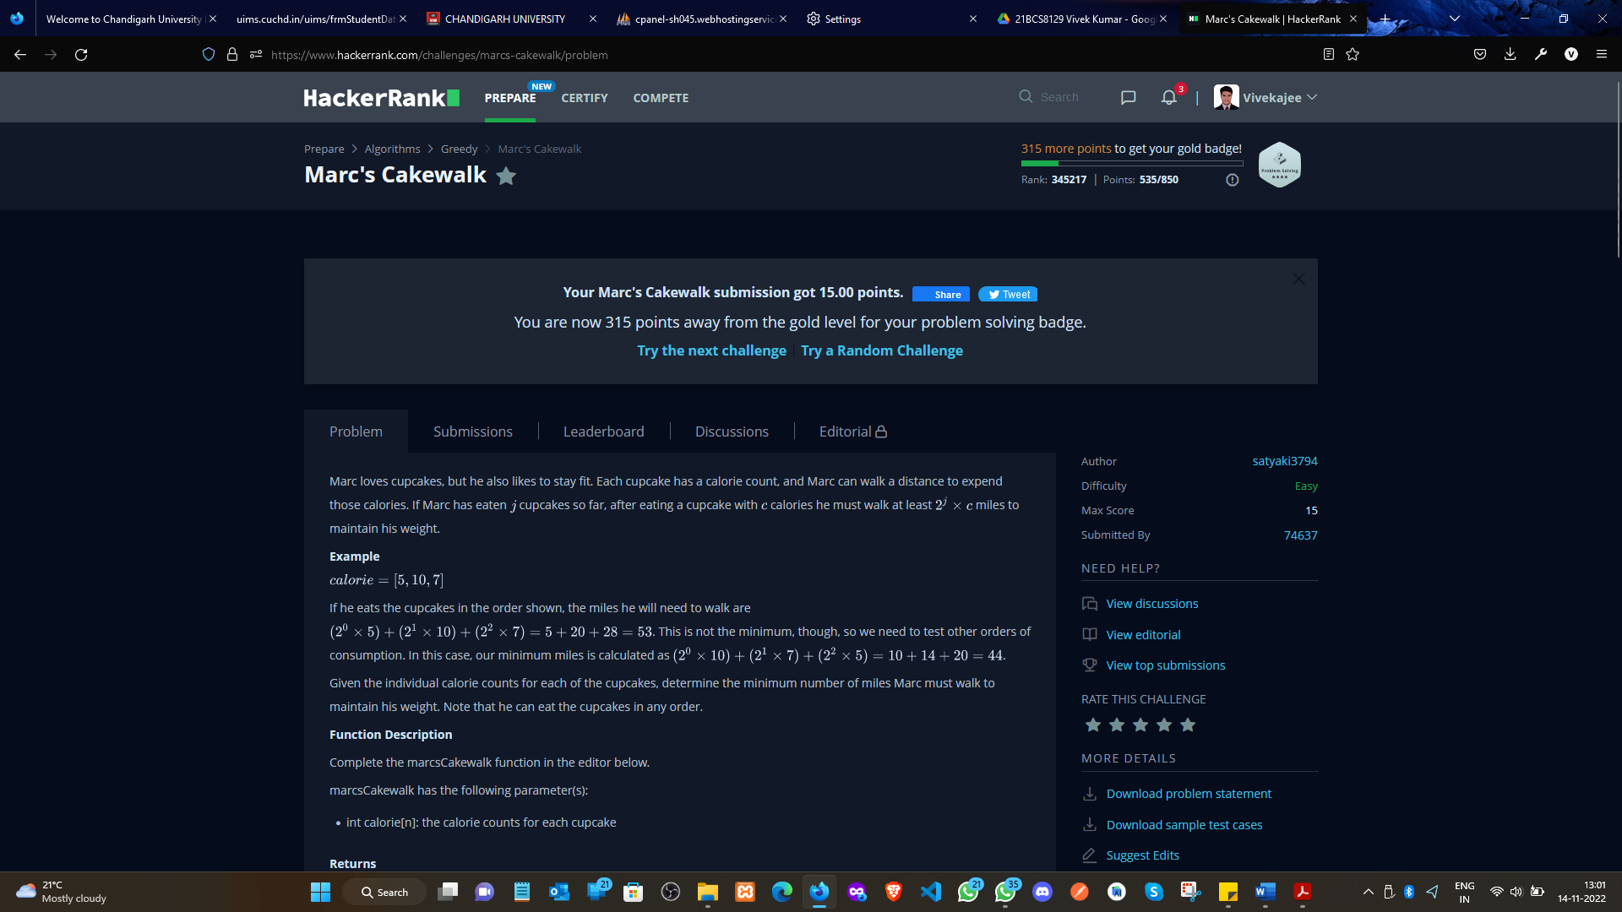

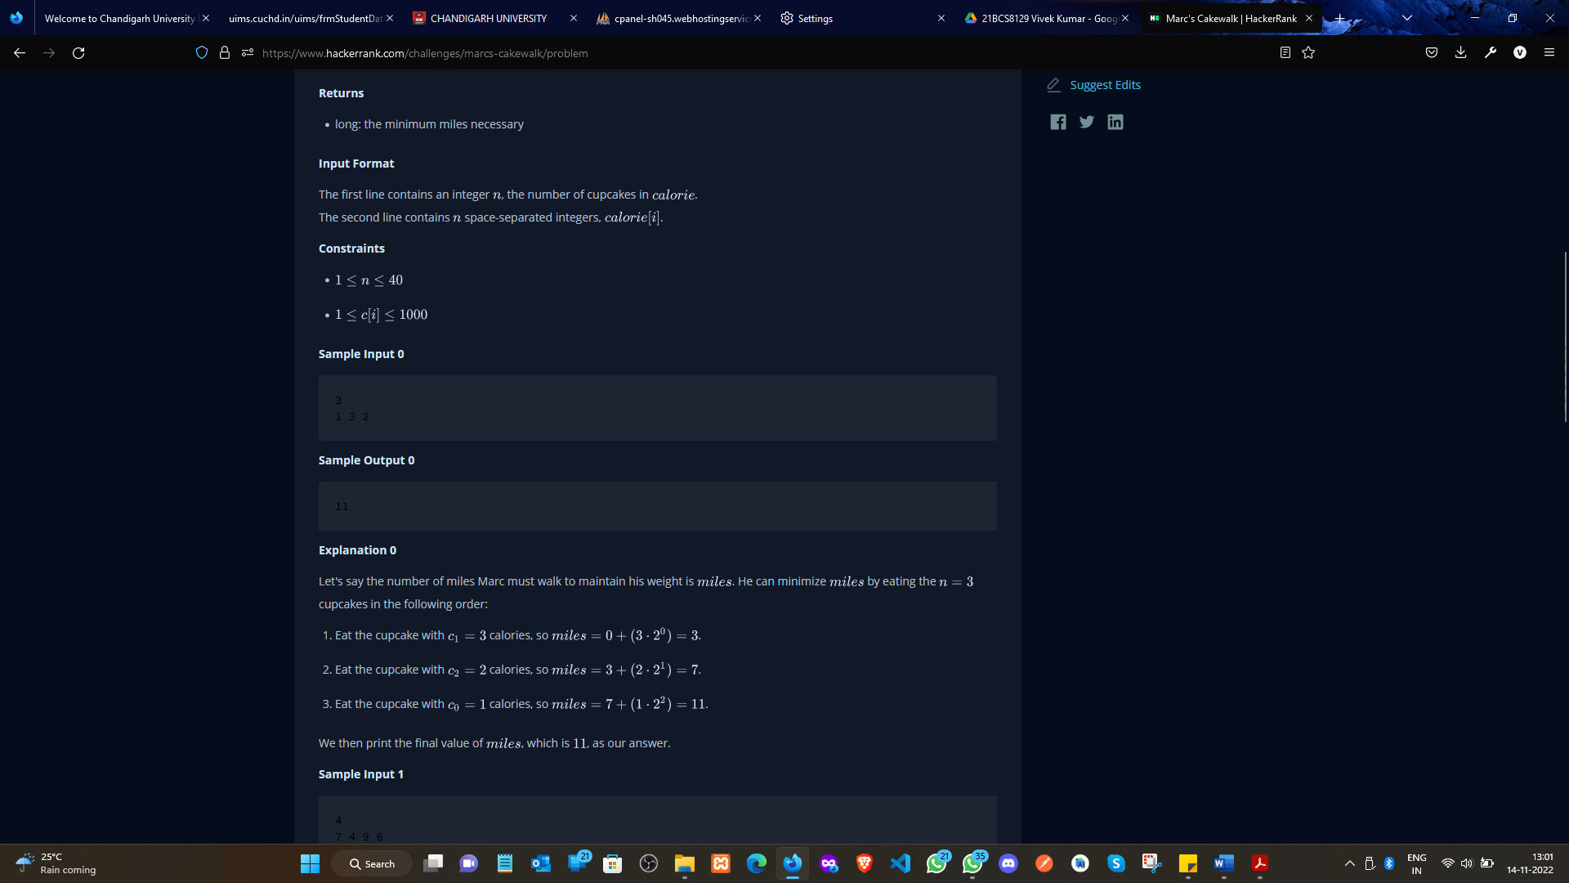

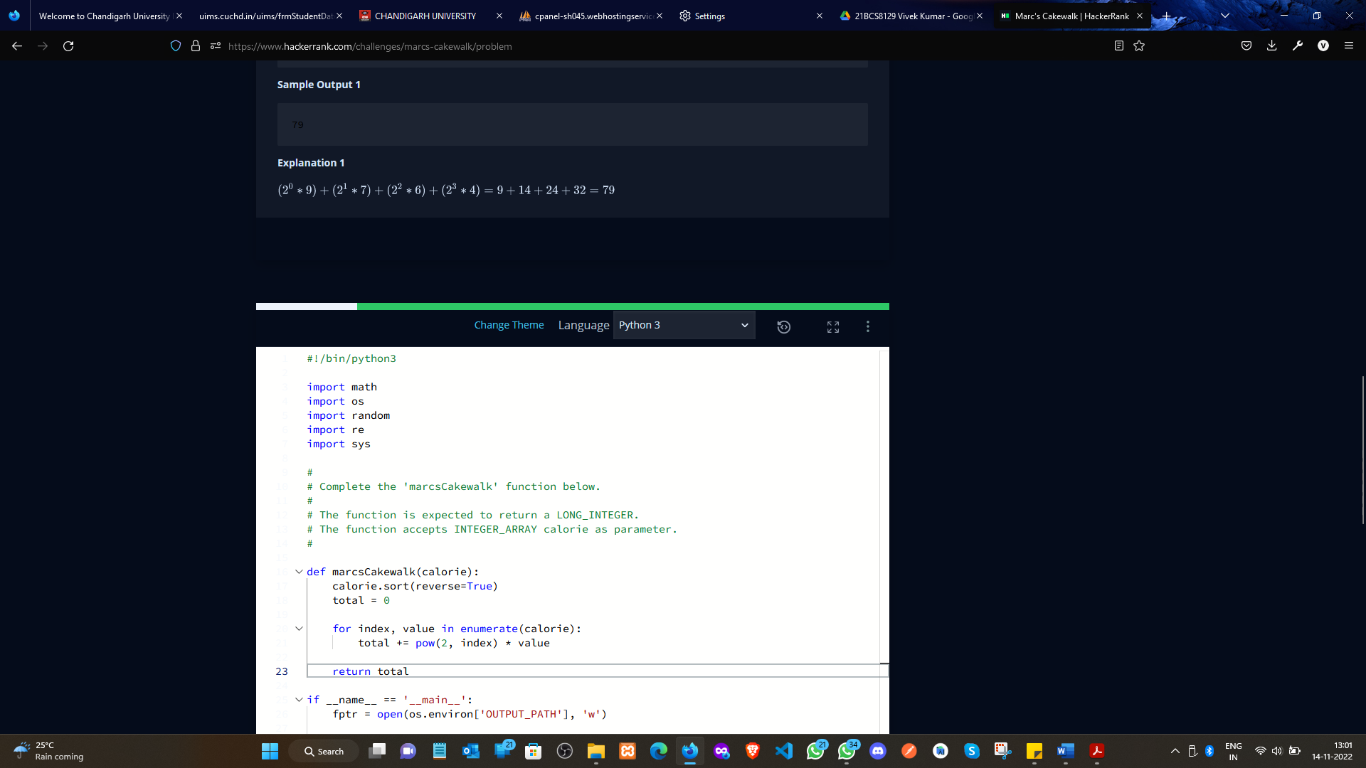

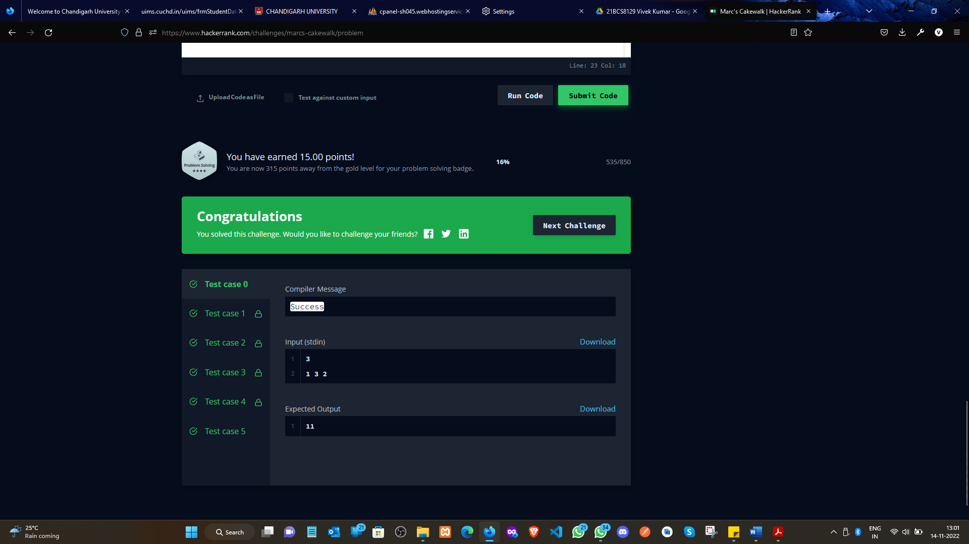

**Experiment 10.2**

1. **Aim/Overview of the practical:**

Branch and Bound, Greedy

Given a square grid of characters in the range ascii[a-z], rearrange elements of each row alphabetically, ascending. Determine if the columns are also in ascending alphabetical order, top to bottom. Return YES if they are or NO if they are not.

<https://www.hackerrank.com/challenges/grid-challenge/problem?isFullScreen=true>

1. **Apparatus / Simulator Used:**

* Windows 7 or above
* Google Chrome

1. **Objective:**
   * To understand the concept of Branch and Bound.
   * To implement the concept of Greedy.
2. **Code:**

#!/bin/python3

import math

import os

import random

import re

import sys

#

# Complete the 'gridChallenge' function below.

#

# The function is expected to return a STRING.

# The function accepts STRING_ARRAY grid as parameter.

#

def gridChallenge(grid):

    sorted_grid = [sorted(row) for row in grid]

    for column in range(len(grid[0])):

        last = sorted_grid[0][column]

        for row in range(1, len(grid)):

            if sorted_grid[row][column] < last:

                return 'NO'

    return 'YES'

if __name__ == '__main__':

    fptr = open(os.environ['OUTPUT_PATH'], 'w')

    t = int(input().strip())

    for t_itr in range(t):

        n = int(input().strip())

        grid = []

        for _ in range(n):

            grid_item = input()

            grid.append(grid_item)

        result = gridChallenge(grid)

        fptr.write(result + '\n')

    fptr.close()

1. **Result/Output/Writing Summary:**

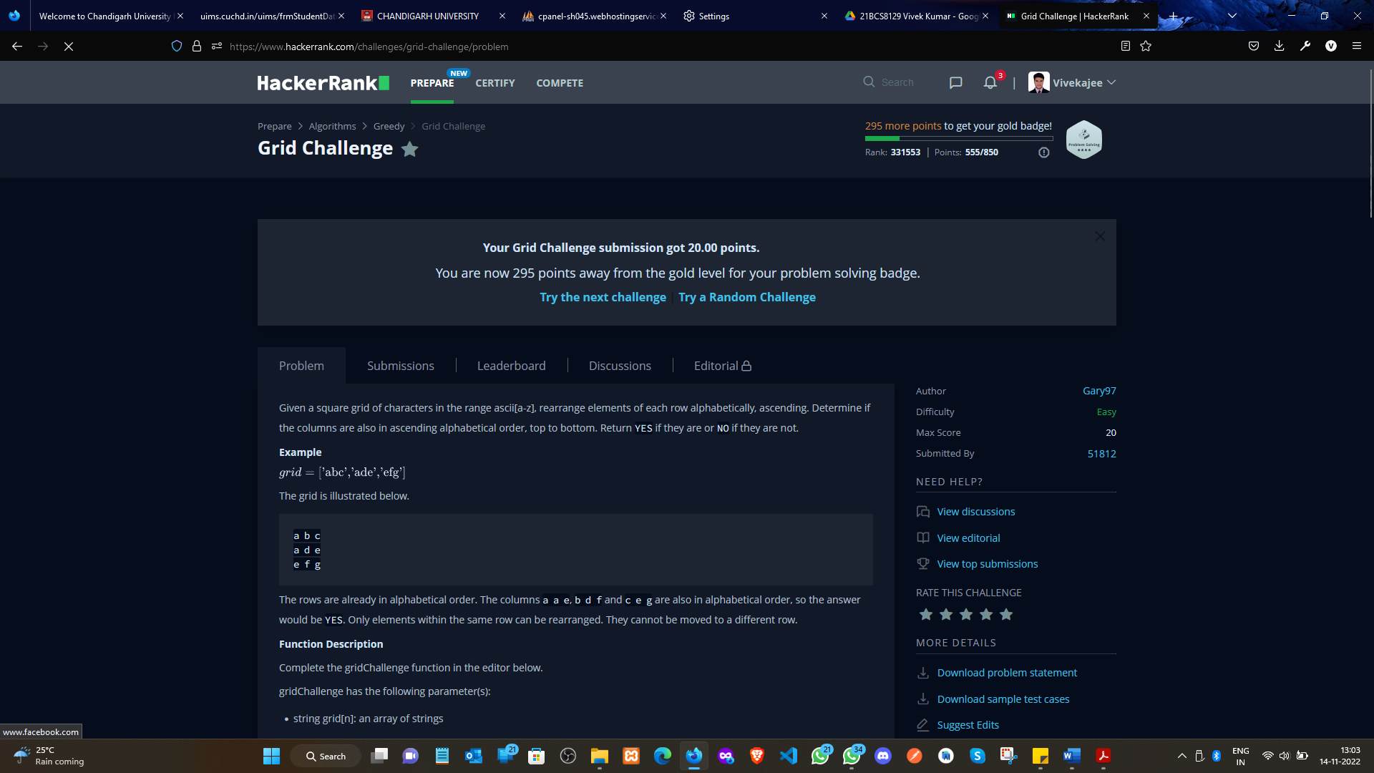

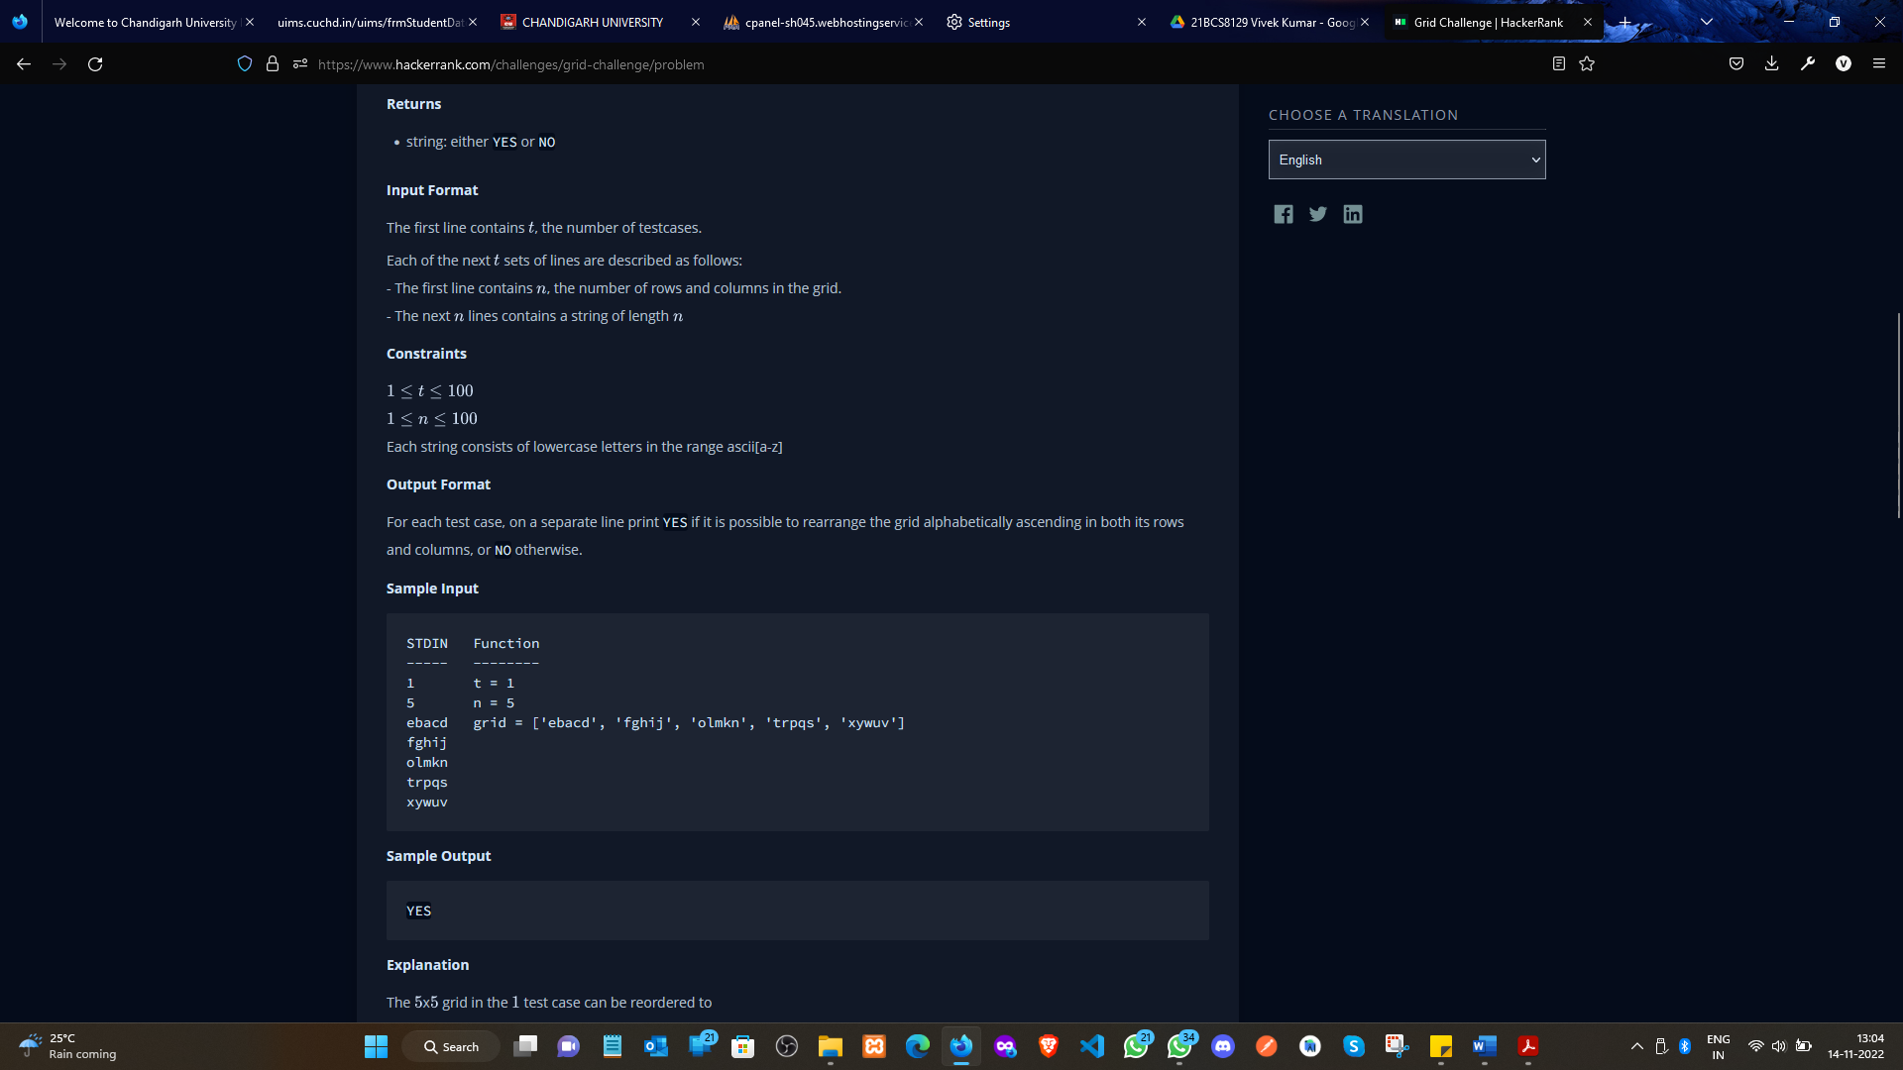

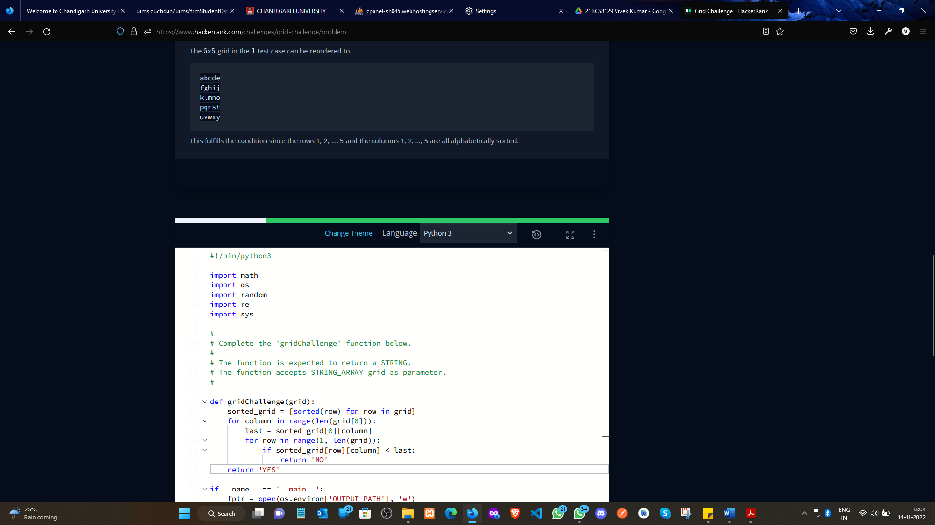

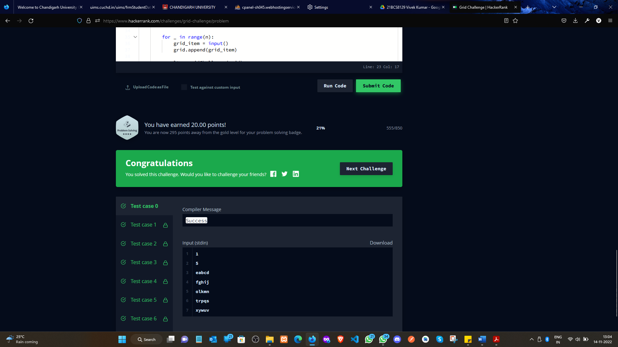

**Learning outcomes (What I have learnt):**

* + Learned the concept of Branch and Bound.
  + Learnt about Array in Greedy.

**Evaluation Grid (To be created per the faculty's SOP and Assessment guidelines):**

|  |  |  |  |
| --- | --- | --- | --- |
| Sr. No. | Parameters | Marks Obtained | Maximum Marks |
| 1. | Worksheet completion including writing learning objectives/Outcomes.  (To be submitted at the end of the day). |  |  |
| 2. | Post-Lab Quiz Result. |  |  |
| 3. | Student Engagement in  Simulation/Demonstration/Performance and Controls/Pre-Lab Questions. |  |  |
|  | Signature of Faculty (with Date): | Total Marks Obtained: |  |